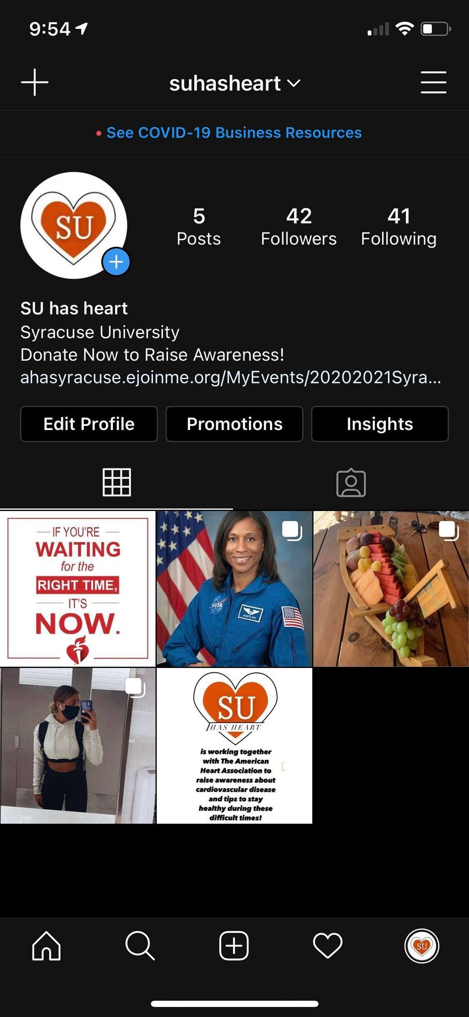

We created this Instagram page called suhasheart. In the bio, it has the link to our donation page.

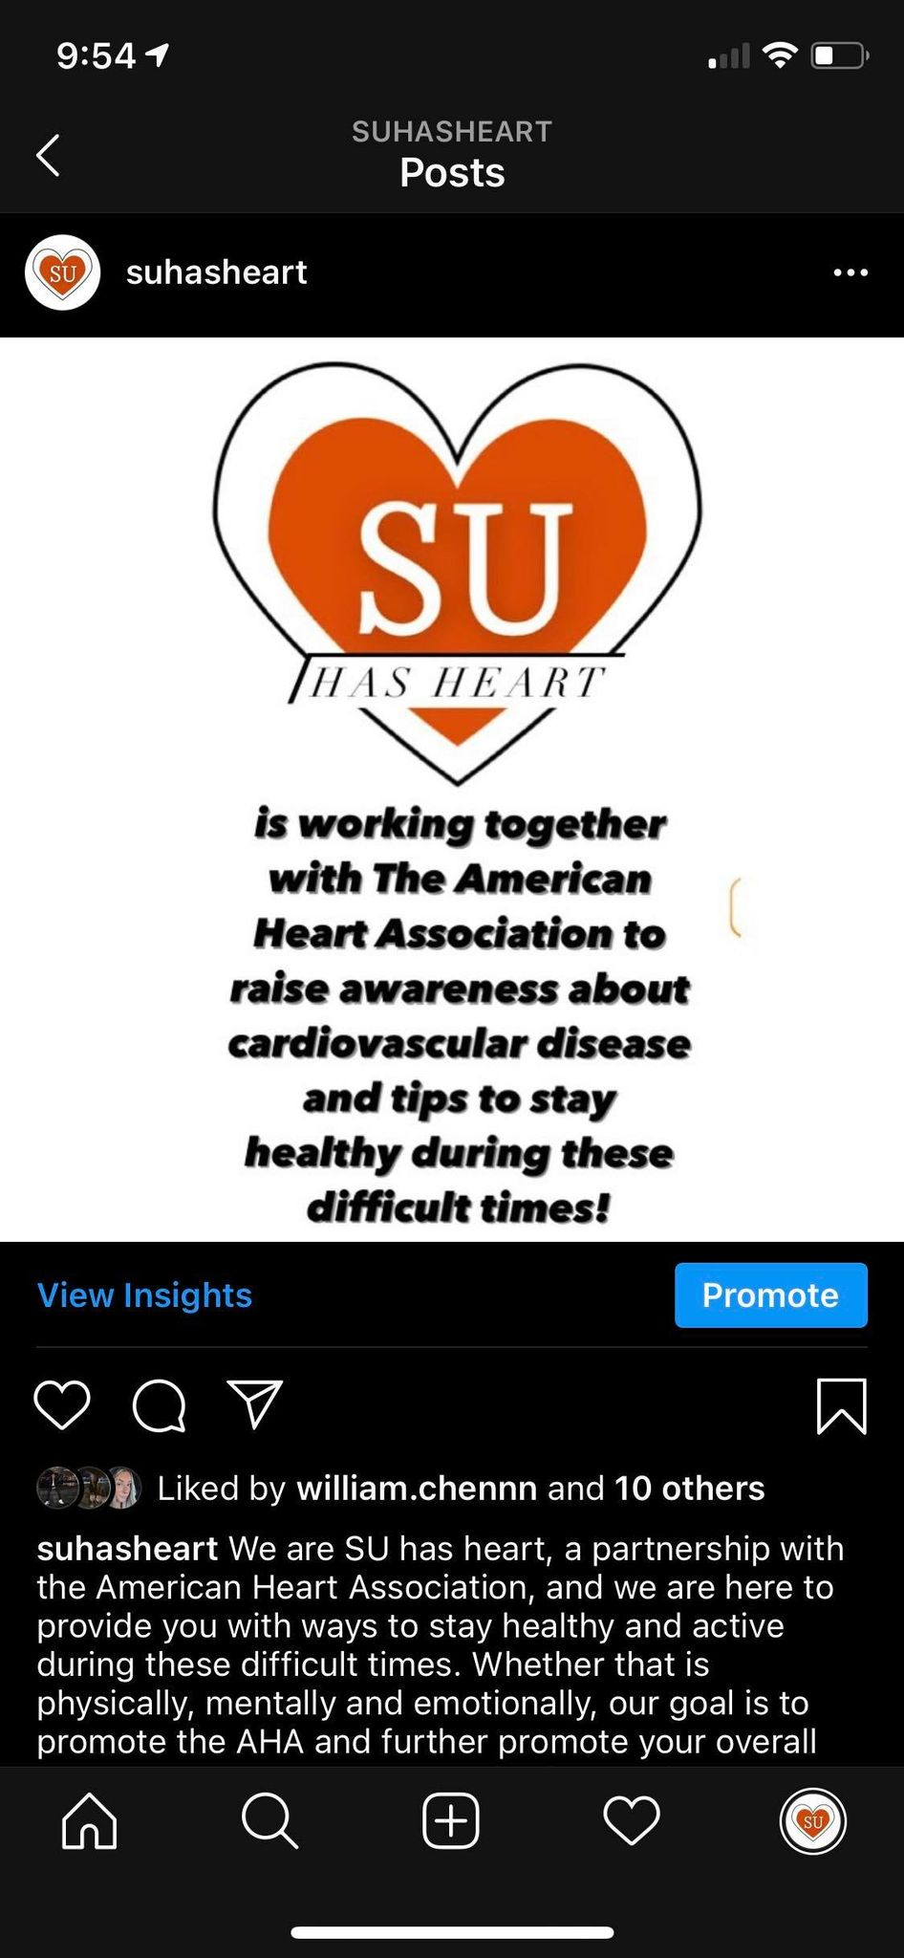

Our first post, introducing ourselves and our purpose.



A post to advertise a zoom meeting held by the AHA to discuss the Syracuse Go Red for Women.

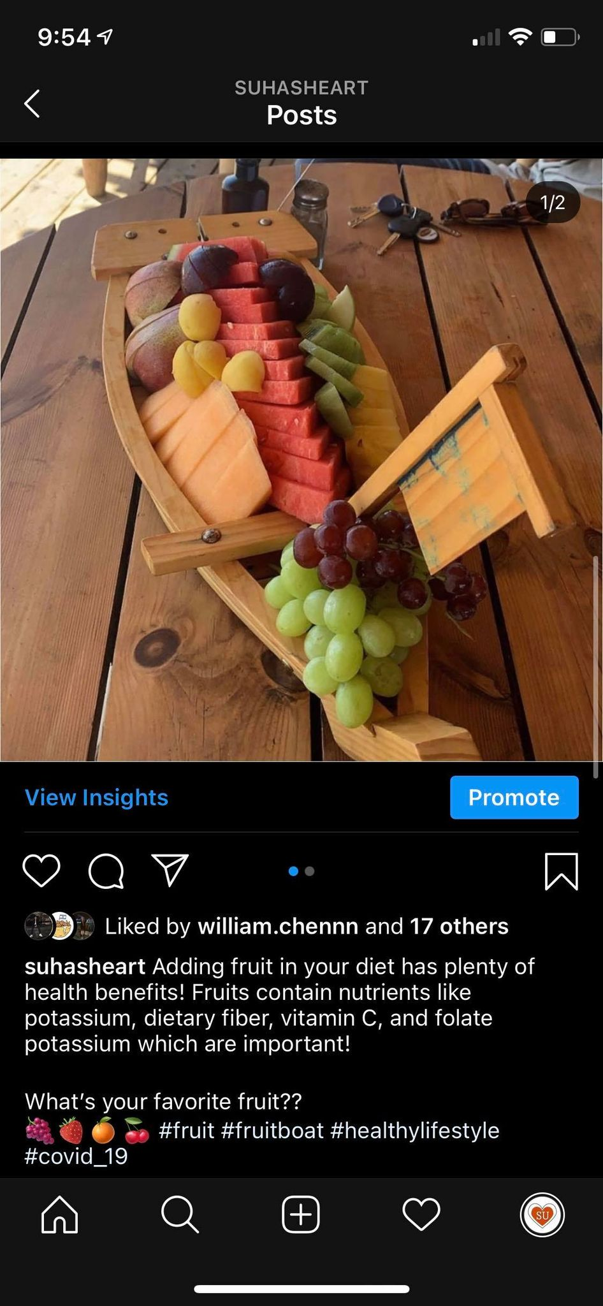

A post encouraging people to have a healthier lifestyle and diet

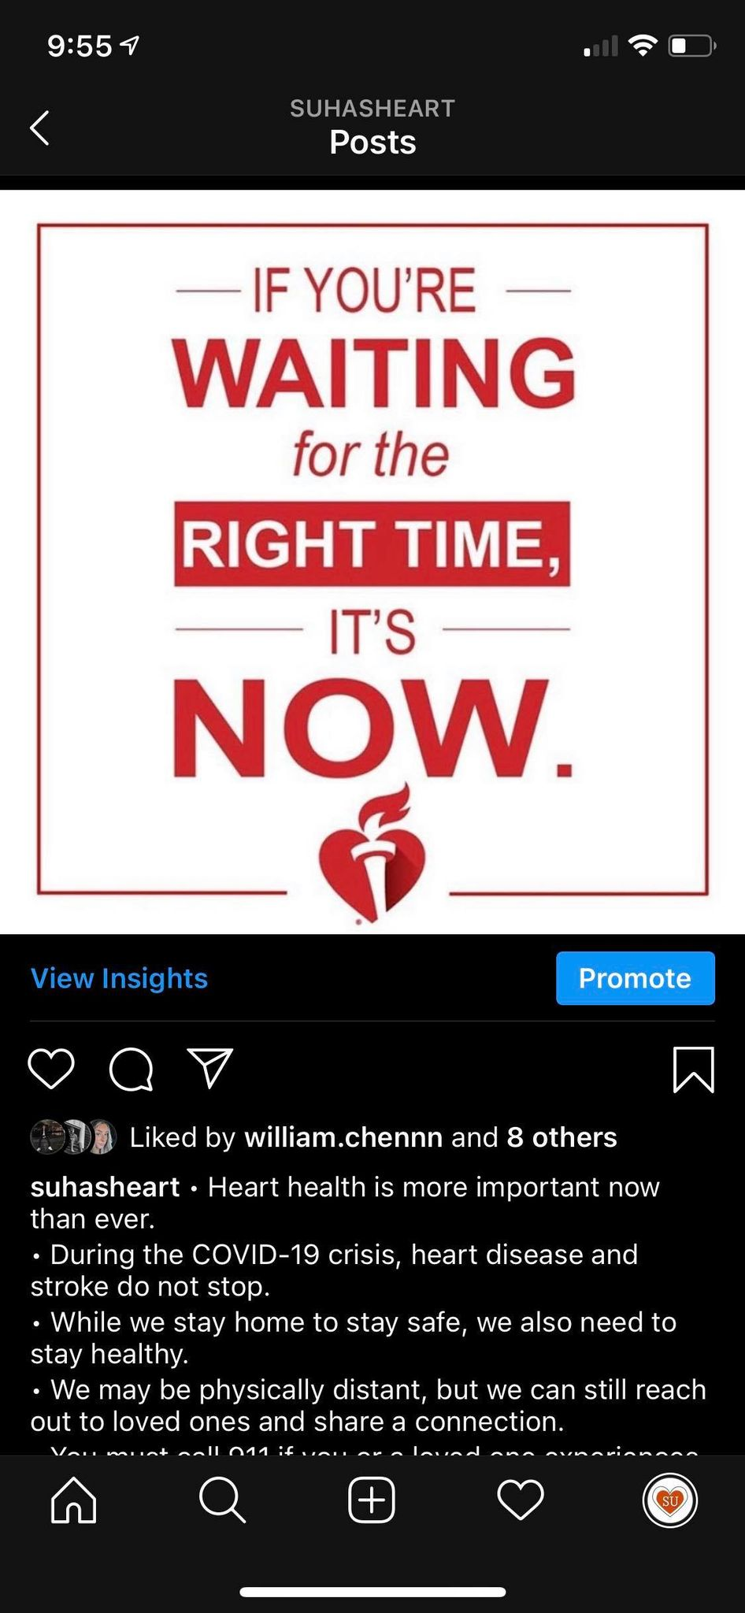

Our latest post, calling attention to learning more about heart health now rather than when it’s too late.